### Predict Heart Failure Using IBM Auto Ai Service

**1 INTRODUCTION**

Heart disease has been the [leading cause of death for decades](https://www.cdc.gov/nchs/products/databriefs/db254.htm). heart disease characterized by when the heart is too weak to pump blood throughout the body, [are on the rise](https://medlineplus.gov/news/fullstory_163266.html).

Heart failure is very hard to detect early, but with the help of a National Institutes of Health (NIH) grant, a team of scientists at IBM Research partnered with scientists from Sutter Health and clinical experts from Geisinger Health System to [study and predict heart failure based on hidden clues in Electronic Health Records (EHRs)](https://www-03.ibm.com/press/us/en/pressrelease/42156.wss). Over the last three years, using the latest advances in artificial intelligence (AI) like natural language processing, machine learning and big data analytics, the team trained models to identify heart failure *one to two years earlier* than a typical diagnosis today. This research uncovered important insights about the practical tradeoffs and types of data needed to train models, and developed new application methods that could allow future models to be more easily adopted.

**2. Flow diagram of Project:**

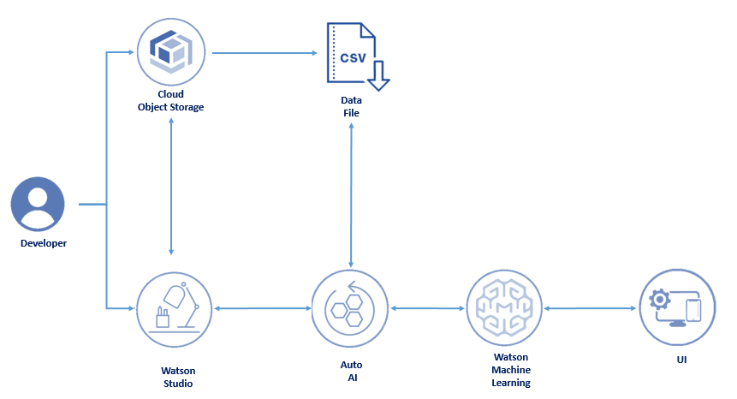

**3.Services Used:**

1. IBM Watson Studio
2. IBM Watson Machine Learning
3. Node-RED
4. IBM Cloud Object Storage

**4. Work flow of an project**

1. Create a account in cloud.ibm.com

**2**.Create a necesary serives

i)IBM Watson Studio

ii)IBM Watson Machine Learning

iii) Associate the cloudstorage sevicex

**3.Open a new project in IBM Watson Studion**

**i) add auto io services**

**ii)** Associate ML to project

**iii)** Load the dataset to Cloud object storage

iv) Select the prediction parameter in the dataset

v)Train the model -using various algorithm in the machine learning model and

save it.

vi)Deploy the model and copy the endpoint ID.

**4.open the node-red services provided**

i) Buid web application using Node-red

ii) install the dash-board to include the form and

iii) Add the appropraite endpoint to the node.

ii) deploy it

**5.Dataset**

The dataset with the parameters

i) AVGHEARTBEATSPERMIN

ii) PALPITATIONSPERDAY

iii) CHOLESTEROL

iv) HEARTFAILURE-prediction

v) SEX

vi) FAMILYHISTORY

vii) SMOKERLAST5YRS

viii)

|  |
| --- |
| EXERCISEMINPERWEEK |

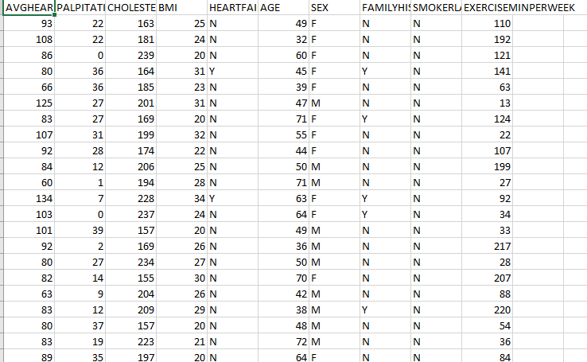

**6. Training phase**

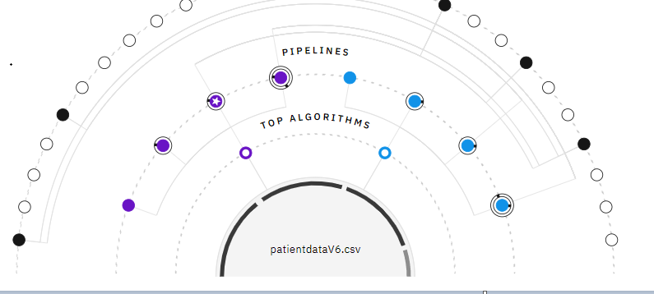

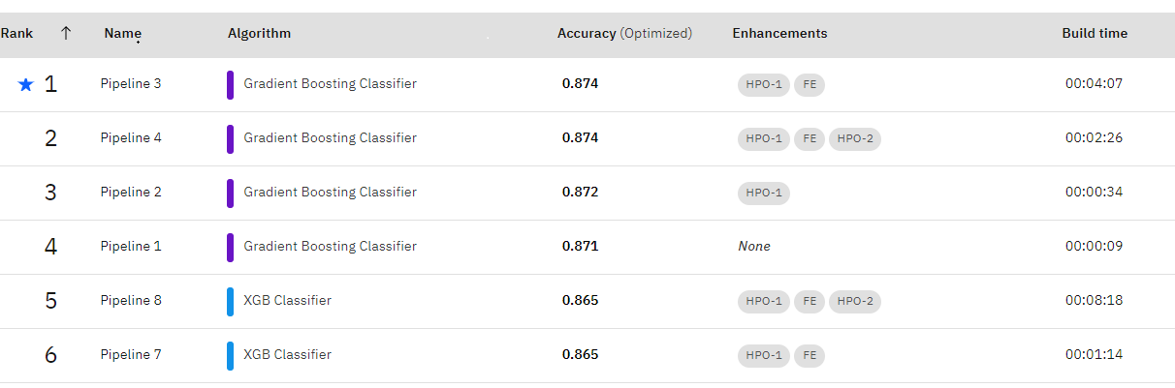

7.front End:

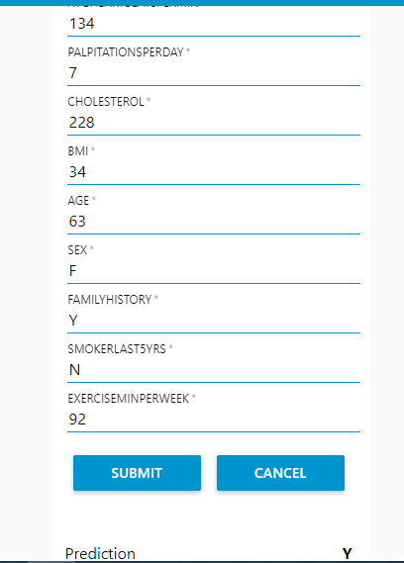

**Conclusion:**

Thus Predict Heart Failure Using IBM Auto Ai Service was devloped using ibm services to accurately predict the possibilty of heart diseases in future.